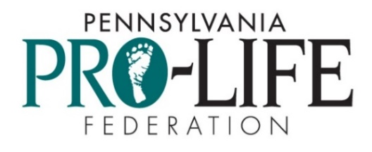

2024 Oratory
Contest Cover Page

Submissions due no later than April 15, 2024
Links to speeches may be emailed to lifelines@paprolife.org
or USB drives can be mailed to
PA Pro-Life Federation
4800 Jonestown Rd. Suite 102
Harrisburg, PA 17109-1741

A written copy of the speech must be submitted. This cover page must be included.
Please print or type.
Name ______________________________________________ Grade__________
Address ____________________________________________
City ___________________________ Zip ________________ Phone _____________________________
Email ___________________________________ School _________________________________
Teacher’s name (if completed as part of a class assignment) _________________________________
Title of Speech (required)_________________________________________________________________
How long is your speech? _______
Additional information:
- Speeches must be an original composition of the submitting student.
- Research is not required. However, if specific statistics are used to support the speech, please provide sources from which you cite.
- The winning speech in the senior division will advance to the National Right to Life Competition. Details will be provided to the winner.
- If using Google docs, please give permission for your documents to be viewed.

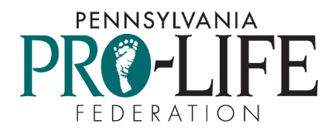
2024 Pennsylvania Pro-Life
Speech Contest Rules

Speak up for those who cannot speak for themselves! The Pennsylvania Pro-Life Federation’s annual Senior High School Pro-Life Speech Contest is open to high school juniors and seniors. The Novice Contest is open to high school freshmen and sophomores.

Students must write and give an original 5-7 minute pro-life speech on abortion, infanticide, assisted suicide, euthanasia, or stem cell research. Students must video record the speech and submit the video and written speech to the Federation by Saturday, April 15, 2024. A panel of judges will review the students’ video-recorded speeches and select first-, second-, and third-place winners out of both the ninth and tenth grade entrants and the eleventh and twelfth grade entrants.

Eligibility
The Pennsylvania Pro-Life Federation Senior Speech Contest is open to Pennsylvania residents who are in 11th and 12th grades. The Novice Contest is open to Pennsylvania residents who are in 9th and 10th grades. Students from other states attending a Pennsylvania school are also eligible.

Submission/Technical Requirements
Students submit their video along with a completed Speech Contest cover sheet and a written copy of their speech. Please note that if information on the cover sheet is lacking, an entrant may be disqualified.

It is preferred that videos of speeches be submitted as a YouTube link. If using YouTube, set the video privacy setting to "Unlisted" so it does not appear in YouTube search results. You can email the link to lifelines@paprolife.org along with the other required items.

Speeches can also be submitted through email in one of the following file extensions: .AVI, .MOV, .MP4, or .WMV. A third way in which speeches can be submitted is through a USB drive that is mailed to the Pennsylvania Pro-Life Federation, 4800 Jonestown Road, Ste. 102, Harrisburg, PA 17109-1741. Once submitted, USB drives will not be returned.

Each video must contain a single student’s speech. Only one entry per student per year. Students who have competed in the previous year may compete the following year with an entirely new speech. However, if a student won first place in the National Right to Life Oratory Contest, that student may not enter our contest again. Second- and third-place winners may compete again.

Rules
1. Contestants must research, write, and present an original pro-life speech on abortion, assisted suicide, infanticide, euthanasia or stem cell research.
2. The speech is to be 5-7 minutes in length. Speeches will be timed when the student begins and ends speaking, not based on the video's length. A contestant will be disqualified if the speech is timed under 4 minutes or over 8 minutes in length. It is at the judges’ discretion how the 4-5 minute and the 7-8 minute speech will reflect in the score.
3. Appropriate gestures are allowed. Props are not allowed.
4. The contestant should use up-to-date factual information.
5. The style should be appropriate to the message of the speech. A dramatic presentation is not acceptable. A dramatic presentation is considered anything that is read or performed that has been previously written by another author; a short story, a poem, etc. Although quotes to support a position or statement are appropriate, they may not dominate the speech, and should be appropriately cited. Dramatic presentations are also defined, for the purposes of this contest, to include acting as a thing or another person, such as acting out the life of an unborn baby. This rule is not to be interpreted to rule out the use of emotion.
6. The speech should appeal to a broad audience.
7. No copyrighted speeches shall be used in the contest.
8. Students are encouraged to know their speeches well. Although use of notes is permitted, reading of speeches is strongly discouraged.
9. The judges score the contestants in four areas; introduction, content, presentation, and conclusion. Contestant’s scores in each area are then added together for the grand total (40 being perfect). The grand total will determine the winners.
10. The judges’ decision will be final.
11. The 11th or 12th grade contestants must be available to represent Pennsylvania in the National Right to Life Oratory Contest. See details below.
Winners and Prizes
A panel of judges will review the students’ video-recorded speeches and select the winners. The first-place winner of the Speech Contest will receive an expense-paid trip for the student and a chaperone to attend the 2024 National Right to Life/Teens for Life Convention in Washington D.C. on June 28-29, 2024. The student will represent Pennsylvania in the National Right to Life Oratory Contest during the convention.

Cash prizes for the other winners of the Speech Contest are: $200 for second-place, $100 for third-place; in the Novice Contest, $300 for first-place, $200 for second-place, and $100 for third-place.

All contestants will be notified of the winners by email. The winning students may be asked to present their speech live in front of a pro-life audience after the contest.

Disclaimer
Submissions may be featured on the Federation's website, social media pages and channels, and at the Federation's discretion. By entering the contest and submitting a video, the contestant grants the Federation the right to post, display, publish, use, and/or modify the submission.

